JFB PTSA Reminders – December 5, 2018

For up to date information, please follow us on Facebook. Just search for JFB PTSA. You may also find us at https://blogs.milton.k12.pa.us/bepsa/

- Gift Card fundraiser orders for December are due in to the school on Tuesday, December 11, 2018. The date is moved up for December so that we can get the order in before Christmas. Forms will not be sent home each month but will be available in the school office if you need one. You may also order online each month. We will let you know when we have them available for pick up.

- Great American Fundraisers Orders were delivered on November 14, 2018. If you haven’t picked up your orders, please pick them up ASAP during regular school hours 7:15am to 3:30PM.
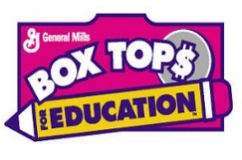
  - Box Tops: Keep Collecting. We will do another competition in the Spring.

- Spirit wear Orders are in. You may pick up your order Tuesday, December 11, 2018 from 2:30-3:30PM and 6-7PM.

- Pasta Fundraiser – Pasta orders can be picked up Tuesday, December 11, 2018 from 2:30-3:30PM and 6-7PM.

Our next meeting is December 11, 2018 at 7:00PM. Everyone is welcome to attend the meetings. At the meetings we talk about fundraisers, upcoming events, and approve teacher requests for class items and field trips. We encourage everyone to come and share their thoughts with us.

